SPS - Bidder Schedule Pickup
Training videos: https://surpluspropertysoftware.com/SPSV2Help/UIPublic/Index.html
Bidder Portal: https://surplus.bo.uiowa.edu/GovDeals/

First Option: After logging in to the bidder portal, select the GovDeals Pickups button from the Home Page to access the pickup screens.
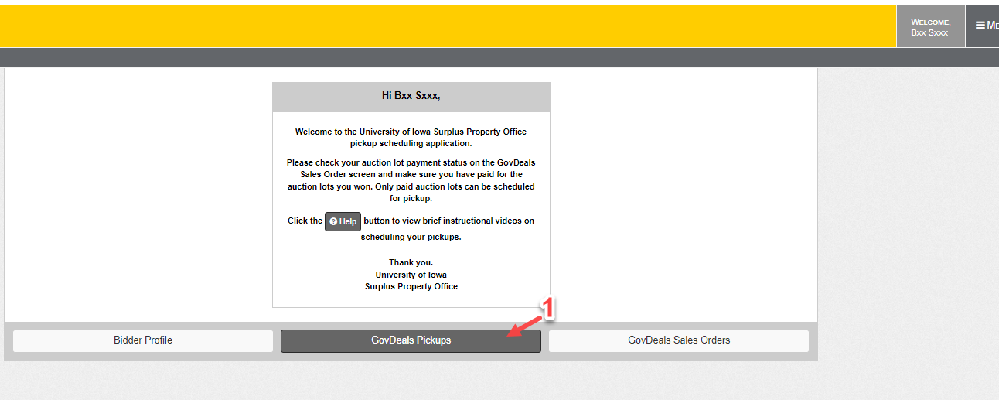

Second Option: Click on the GovDeals Pickups in the Menu toolbar to access the pickup screens.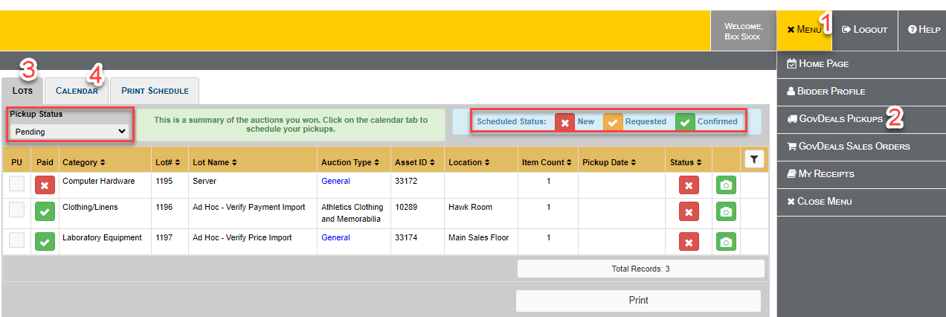
#3 (Lots tab): The lots report will list all the lots based on the Pickup Status. Current report is listing all three pending lots that are waiting for scheduling.
#4(Calendar tab): Schedule your pickup by selecting a time slot from the calendar tab.

#4(Calendar tab): Schedule your pickup by Self
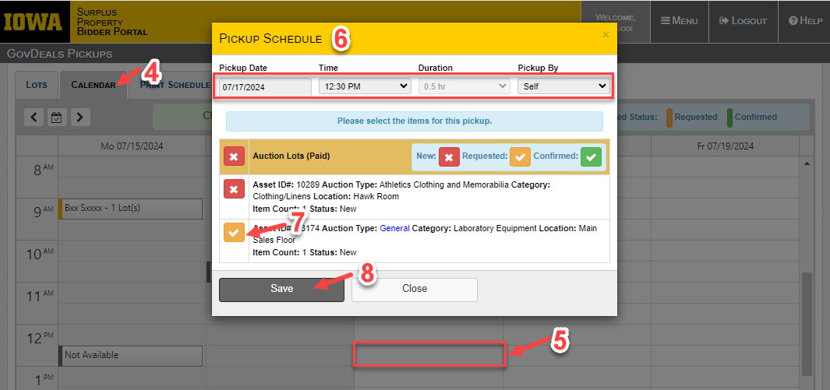

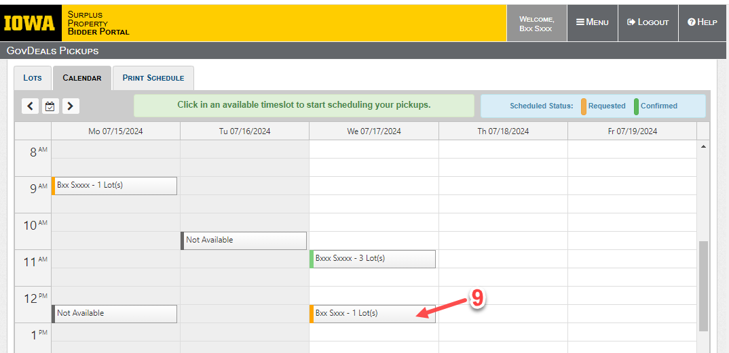

Upon confirmation of the Surplus, you can check all confirmed pickup schedules in the Lots tab and the Print Schedules screens.
Lots:
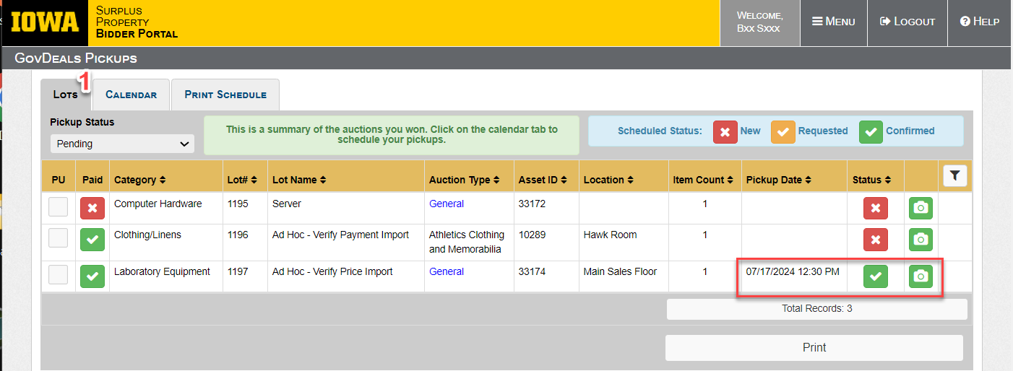

Print Schedules:
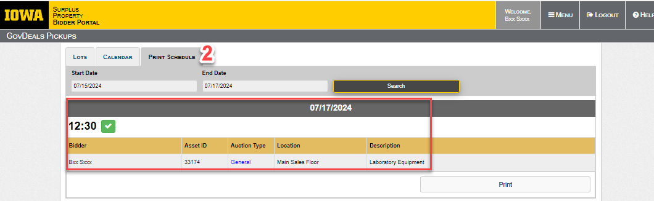

#4(Calendar tab): Schedule your pickup by Other Person
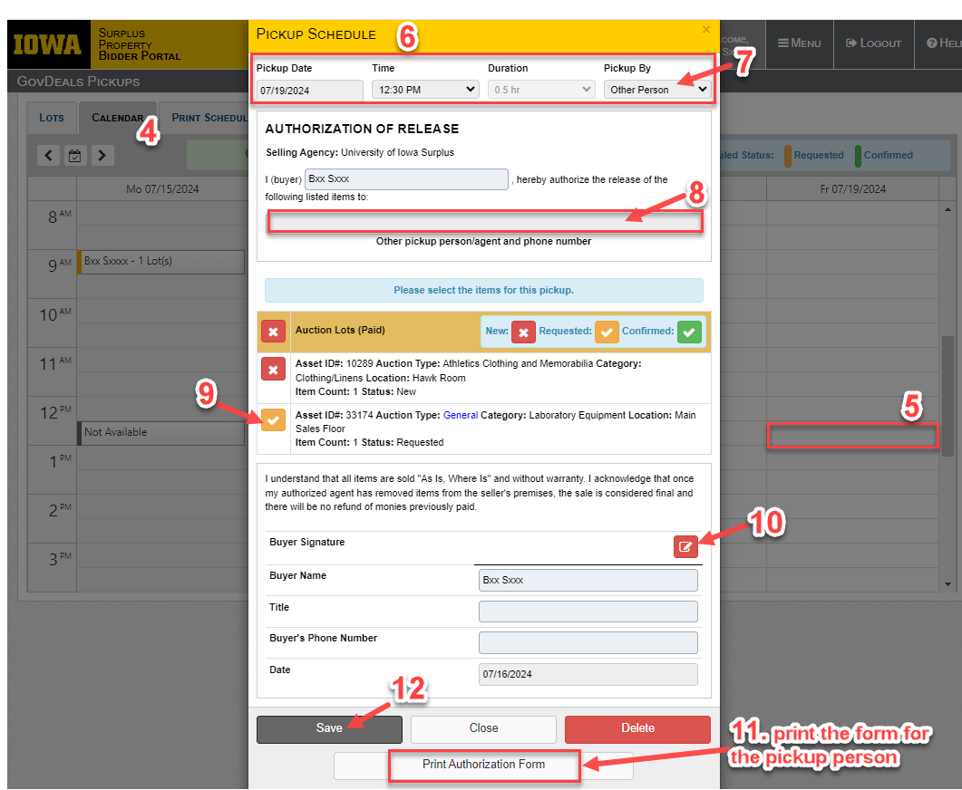

#4(Calendar tab): Schedule your pickup by Shipper
