SPS - Add Favorite MFK
Training videos: https://surpluspropertysoftware.com/Iowa/DisposalRequests.html
Surplus Disposal Application: https://surplus.bo.uiowa.edu/SurplusPropertySystem/
Restricted to IACTs: 4401, 6070, 6085, 6115, 6199 and 7055
- Add favorite MFK in the User profile
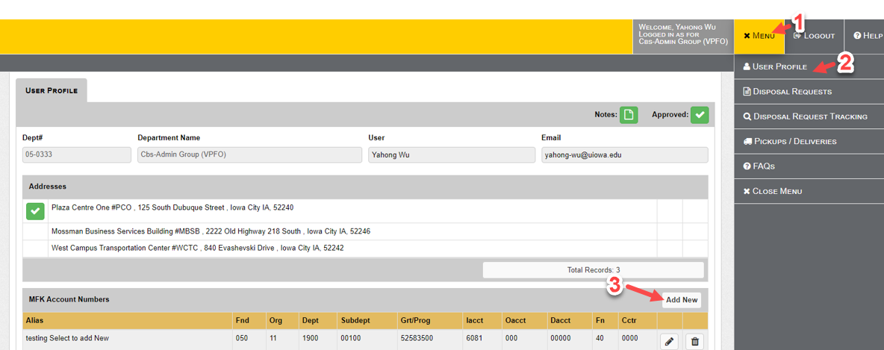

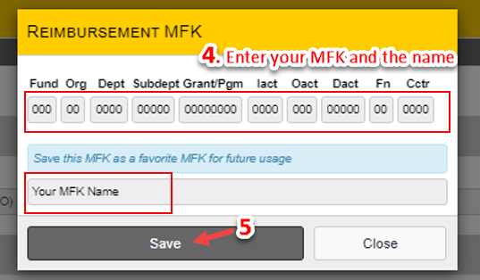

- Add favorite MFK when creating a disposal request
